The Strange Case of BeriBeri
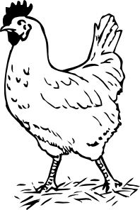
In 1887 a strange nerve disease attacked the people in the Dutch East Indies. The disease was beriberi. Symptoms of the disease included weakness and loss of appetite, victims often died of heart failure. Scientists thought the disease might be caused by bacteria. They injected chickens with bacteria from the blood of patients with beriberi. The injected chickens became sick. However, so did a group of chickens that were not injected with bacteria.
One of the scientists, Dr. Eijkman, noticed something. Before the experiment, all the chickens had eaten whole-grain rice, but during the experiment, the chickens were fed polished rice. Dr. Eijkman researched this interesting case and found that polished rice lacked thiamine, a vitamin necessary for good health.
1. State the Problem

2. What was the hypothesis?

3. How was the hypothesis tested?

4. Should the hypothesis be supported or rejected based on the experiment?

5. What should be the new hypothesis and how would you test it?

How Penicillin Was Discovered
In 1928, Sir Alexander Fleming was studying Staphylococcus bacteria growing in culture dishes. He noticed that a mold called Penicillium was also growing in some of the dishes. A clear area existed around the mold because all the bacteria that had grown in this area had died. In the culture dishes without the mold, no clear areas were present.
Fleming hypothesized that the mold must be producing a chemical that killed the bacteria. He decided to isolate this substance and test it to see if it would kill bacteria. Fleming transferred the mold to a nutrient broth solution. This solution contained all the materials the mold needed to grow. After the mold grew, he removed it from the nutrient broth. Fleming then added the nutrient broth in which the mold had grown to a culture of bacteria. He observed that the bacteria died which was later used to develop antibiotics used to treat a variety of diseases.
6. Identify the problem.

7. What was Fleming's hypothesis?

8. How was the hypothesis tested?

9. Should the hypothesis be supported or rejected based on the experiment?

10. This experiment lead to the development of what major medical advancement?

