Physical / Chemical Change Rhyme
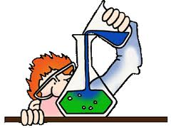

A Physical Change changes how things look,
Like tearing the pages of a book,
Or freezing a liquid, like water to ice,
Or painting a house to make it look nice.

A Chemical Change has come to pass
If you can see a new solid, liquid or gas.
The color may change or the energy too.
A Chemical Change makes something new.

