Ionic Covalent Bond
Vocabulary
- Anion: An ion that has a negative charge.
- Atom: The smallest unit of an element that retains the chemical properties of the element. Atoms can exist alone or in combinations with other atoms forming molecules.
- Cation: An ion that has a positive charge.
- Chemical Bond: A link between atoms.
- Compound: A substance formed by the chemical combination of elements in defined proportions.
- Covalent Bond: A chemical bond formed by the sharing of electrons between atoms.
- Dipole: The uneven distribution of electrical charge across a polar molecule.
- Electronegativity: A measure of the attraction of an atom for the electrons in a covalent bond.
- Ion: An atom that has acquired an electrical charge by either gaining or losing electrons.
- Ionic Bond: Bond formed between oppositely charged ions because of electrostatic forces of attraction.
- Ionic Compound: A compound formed by ions.
- Lewis Dot Structure: A diagram to represent the valence electrons of an atom, written as the element symbol surrounded by dots that represent the valence electrons. Also used to represent bonding between atoms.
- Molecule: A unit of matter formed by the chemical bonding of two or more atoms by covalent bonds.
- Neutral Atom: An atom with equal numbers of protons and electrons.
- Octet Rule (Noble Gas Rule): Rule that states that atoms tend to combine in such a way that they each have eight electrons in the highest main energy level, giving them the same electronic configuration as a noble gas.
- Valence Electron: Electrons in the outermost energy level of an atom; Electrons that can be involved in chemical bonding.

Ionic Covalent Bond
Diagram Configuration

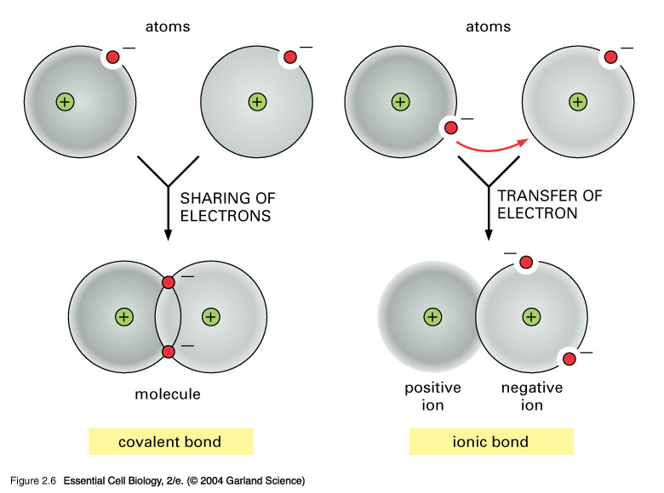

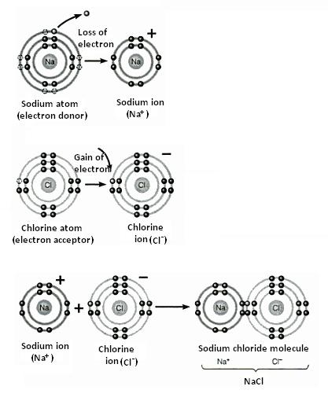

Ionic Bond Salt NaCl

