Name: _______________________________________ Date: _____________
Room: ___________
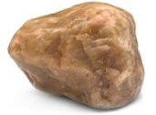
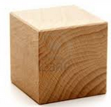
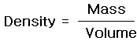
Properties of Matter

Part I
- What is the mass of the cube? __________
- What is the volume of the cube? (Show your work) _________

- What is the density of the cube? (Show you work) ___________

Part II
- What is the mass of your rock? _______________
- What is the volume of your rock? _______________
Explain how you got your answer: _________________________________________________________________________________________________________________________________________________________________________________________________________________________________________________________________________________________________________________________________________________________
- What is the density of the rock? (Show your work) ___________

Part III
- What are the four properties of matter?
1.___________________ 3.____________________
2.___________________ 4.____________________

